**MAJOR PROJECT**

**QUANTICO**

**TEAM MEMBERS:-**

***Y.Praneeth (12K81A05J0)***

***Y.Keshav (12K81A05H9)***

***G.Vamshi Krishna (12K81A05D9)***

***L.Eswar Reddy (12K81A05E8)***

CLASS:- CSE-4C

COLLEGE:- ST.MARTIN’S ENGINEERING COLLEGE

INTRODUCTION

The purpose of my project was to model an application that is capable of converting a value of currency into another. Different countries use different currency, and there is daily variation in these currencies relative to one another. Those who transfer money from one country to another (one currency to another) must be updated with the latest currency exchange rates in the market. This can be done by introducing values to the application by retrieving values from the internet that corresponds to an appropriate sum of currency value. In retrieving values from the internet, the application makes use of a special method that invokes another method or entity of objects present in a cloud fare.

For this to happen, first User has to choose a currency type from a list of 153 various currencies. He also has to choose which currency type, it should be converted to. He follows the same process that he did for choosing the currency value to convert from. Since the sample space is more than 153, some internet and web-based application may find it difficult to retrieve the values in run time and with speed and agility. But this application can convert a value of a given currency into another in real time just as we enter the value of the currency that we want to convert from. Hence it makes this application affective as well as efficient to use. The user interface that is built into this application is unbelievably comfortable and User friendly.

* **The game is finished when all**

***Proposed android system:-***

* **It is a Java application that is designed to work in Android operating system (above 4.0).**

**ARCHITECTURE:-**

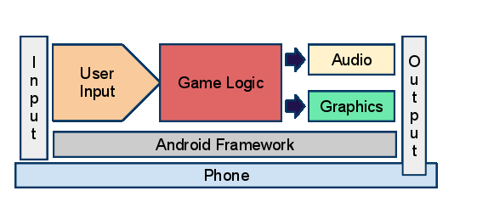

**UML diagram:-**

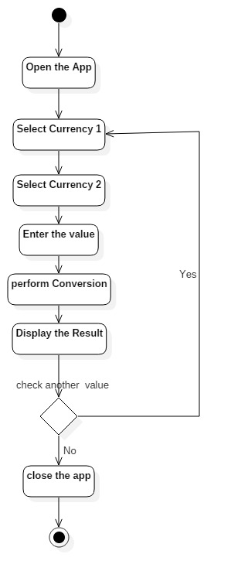

**Software Requirements:-**

1. **Android mobile with a minimum version 4.0.**

**Hardware requirements:-**

1. **Processor is not less than 500MHZ.**
2. **RAM is not less than 512MB.**
3. **SD card with minimum of 1GB.**
4. **Resolution is not less than 480*800pixs.**